|  |  |
| --- | --- |
| TRUE | "What will be the value of intResult or booleanResult if we execute the following expressions? booleanResult = !((a + c) > b) && x;" |
| 1 | "What will be the value of intResult or booleanResult if we execute the following expressions? intResult = 1;" |
| The program will display message dialog box. | What will happen if you use JOptionPane.showMessageDialog statement in your program? |
| All of the choices | Which of the following is a valid nexDouble() return value? |
| nextLine() | Which of the following method reads input from the user and return String value? |
| 1010 | Which of the following is a valid nextInt() return value? |
| None of the choices | Which of the following is a valid statement to accept int input? Let us assume that we have declared scan as Scanner. |
| String | What type of value does the nextLine() returns? |
| 3 | Which of the following is a valid nextByte() return value? |
| The program will display an input dialog box that allows the user to input text and returns String value. | What will happen if you use JOptionPane. showInputDialog statement in your program? |
| None of the choices | Which of the following does not return numeric value? |
| String str = JOptionPane.showInputDialog(""); | Which of the following is a valid statement to accept String input? |
| print "Hello World" infinitely | "What will be the output if you execute this code? do{System.out.println(""Hello World!"");}while(true);" |
| All of the statements are correct | What is floating-point literal? |
| None of the choices | Which of the following is not usable for writing java source code? |
| int x = 1; | Which of the following is not a valid variable declaration in Java? |
| None of the above | "What will be the value of x after you execute this statement int z=0; for(int x=0; x<10 for="" int="" td="" x="" y="" z=""> |
| name | Which of the following is not a java keyword? |
| none of the choices | Which statement will check if x is equal to y? |
| javac HelloWorld.java | What is the correct statement to compile Java program in command line? |
| Oak | What was the initial name for the Java programming language? |
| Static | Which of the following is not the feature of java? |
| if (x | Which statement will check if x is less than y? |
| Interpreting bytecode | JVM is responsible for |
| none of the choices | Which of the following is not an escape sequence? |
| name | Which of the following is a valid identifier? |
| All of the statements are true | Which of the following is true about syntax errors: |
| None of the choices | Which of the following is a valid statement to accept int input? Let us assume that we have declared scan as Scanner. |
| Byte Code | What did java generates after compiling the java source code? |
| java HelloWorld | What is the correct statement to run Java program in command line? |
| There will be a syntax error after compilation. | What will happen if we compile the statement below? ~System.out.println(“Hello World!”) |
| Multithreaded | The feature of Java which makes it possible to execute several tasks simultaneously. |
| String str = JOptionPane.showInputDialog(""); | Which of the following is a valid statement to accept String input? |
| Runtime errors occur during run-time. | Which of the following is true about Runtime errors: |
| None of the choices | Which of the following is not Java Literal? |
| print "Hello World" | "What will be the output if you execute this code? do{System.out.println(""Hello World!"");}while(false)" |
| . Platform independent | The Java feature, "write once, run anywhere", is termed as |
| All of the choices | Which of the following is a valid nexDouble() return value? |
| Declaration Comments | Which of the following is not a Java comment? |
| It depends, if there is a compiler embedded in Notepad. | Can we directly compile codes from notepad? |
| none of the choices or all | Which of the following is not a valid Float value? |
| C:\Program Files\Java\jdk1.6.0_23\bin | What is the correct statement to set JavaC path in command line? |
| id_1 | Which of the following a valid Java identifier? |
| if (boolean_expression) | Which of the following has the correct form for an if statement? |
| None of the choices | Which of the following we are not allowed to write java source code? |
| String | Which of the following is not a primitive data type? |
| The program will display message dialog box. | What will happen if you use JOptionPane.showMessageDialog statement in your program? |
| 11 | What will be the value of x after executing this code |
| None of the choices | Which is not a decision control structure? |
| Source Code | What is the input for Java Compiler? |
| switch | Which is not a repetition control structure? |
| TRUE | "What will be the value of intResult or booleanResult if we execute the following expressions? booleanResult = x && y || x;" |
| 765321 | "What is the output of the code snippet below: int[] intArray = { 1, 2, 3, 5, 6, 7 }; for(int x = intArray.length-1; x>=0; x--){System.out.print(intArray[x]);}" |
| 5 | From the array int[] intArray = { 1, 2, 3, 5, 6, 7 };, what is the value of intArray[3]? |
| 5 | What is the maximum index of the array: int[] intArray = { 1, 2, 3, 5, 6, 7 }; |
| stringArray[5]; | Which of the following correctly accesses the sixth element stored in an array of 10 elements? |
| All of the choices | Which of the following is a valid multidimensional array? |
| 6 | What is the length of the array: int[] intArray = { 1, 2, 3, 5, 6, 7 }; |
| stringArray[5]; | Which of the following correctly accesses the sixth element stored in an array of 10 elements? |
| All of the choices | Which of the following declares an array of int named intArray? |
| 0 | "int[] intArray = new int[10]; for(int x = 0; x |
| 29 | What is the index number of the last element of an array with 30 elements? |
| compute | Which of the following is a valid method name: |
| 111111 | "void main(){test(“11”);test(“1”);} void test(String x){System.out.print(x + x);}" |
| test | What is the name of this method: int test(){return 1;} ? |
| none of the choices | Which of the following shows a valid Overloading method? |
| void test(int x){} void test(double x){} | Which of the following shows Overloading method? |
| int | What is the return type of this method: int test(){return 1;} ? |
| 1 | What is the return value of this method: int test(){return 1;} ? |
| void | What is the return value of this method: public void sum(){int x=1;} ? |
| none of the choices | Which of the following shows a valid Overloading method? |
| 11 | What is the output of the code snippet below: void main(){test();test();} void test(){System.out.print(“1”);} |
| 1.01 | What is the output of the code snippet below: |
| java | What is the extension name of a Java Source code? |
| test | What is the name of this method: int test(){return 1;} ? |
| none of the choices | Which of the following shows a valid Overloading method? |
| 1 | What is the return value of this method: int test(){return 1;} ? |
| Class Variable | What do you call a variable that belong to the whole class? |
| Class | What do you call a blueprint of an object? |
| true | What is the result if we execute this: “a”.equals(“a”);? |
| Encapsulation | It is the method of hiding certain elements of the implementation of a certain class? |
| All of the choices | Which of the following show casting object? |
| Class | It is a template for creating an object? |
| All of the choices | Which of the following creates an instance of a class? |
| . int 25 | What will be the value of x if we execute this: String s = "25"; int x = Integer.parseInt(s); ? |
| true | What is the result if we execute this: “a” instanceof String; ? |
| short x=1; int y = x; | Which of the following will do implicit cast? |
| Polymorphism | It is the ability of an object to have many forms? |
| Subclass | What do you call a class that inherits a class? |
| All of the statements are correc | Which of the following is true about Interface? |
| public interface [InterfaceName] {} | Which of the following is the correct way to define an interface? |
| public final void setName(){} | Which of the following method is allowed to be overriden? |
| public abstract class Person {} | Which of the following class declaration is not allowed to be instantiated? |
| super | Which of the following is the correct way to call the constructor of the parent class? |
| extends | What keyword is used to perform class inheritance? |
| public final class Person {} | Which of the following class declaration is not allowed to be inherited? |
| public class Person implements [InterfaceName] {} | Which of the following is the correct way to use an interface? |
| 19 | What is the index number of the last element of an array with 20 elements? |
| package ; | Which of the following is the correct syntax to define a method? |
| short x=1; int y = x; | Which of the following will do implicit cast? |
| Interpreting bytecode | What is the function of JVM? |
| test | What is the name of this method: int test(){return 1;} ? |
| 1.01 | "void main(){test(1.0); test(1);} void test(double x){ System.out.print(x); void test(int x){System.out.print(x);}" |
| 12 | What will be the value of x after executing this code for(int x=0; x<=11; x++) {} is run? |
| "int a[] = new int[1]; System.out.println(a[1]);" | What will be the output if you execute this code: |
| 4 | From the array int[] intArray = { 1, 2, 3, 5, 6, 7 };, what is the value of intArray[2]? |
| Accessor | It used to read values from class variables? |
| . Oak | What was the initial name of the Java programming language? |
| 1 | What is the return value of this method: int test(){return 1;} ? |
| Static | Which of the following is not the feature of java? |
| 35087 | When was the officially released of Java? |
| Yes, because we can call Java compiler from NetBeans | Can we directly compile codes from NetBeans? |
| short x=1; int y = x | Which of the following will do implicit cast? |
| To make JavaC available or accessible in command line. | Why do we need to set the path for JavaC in command line? |

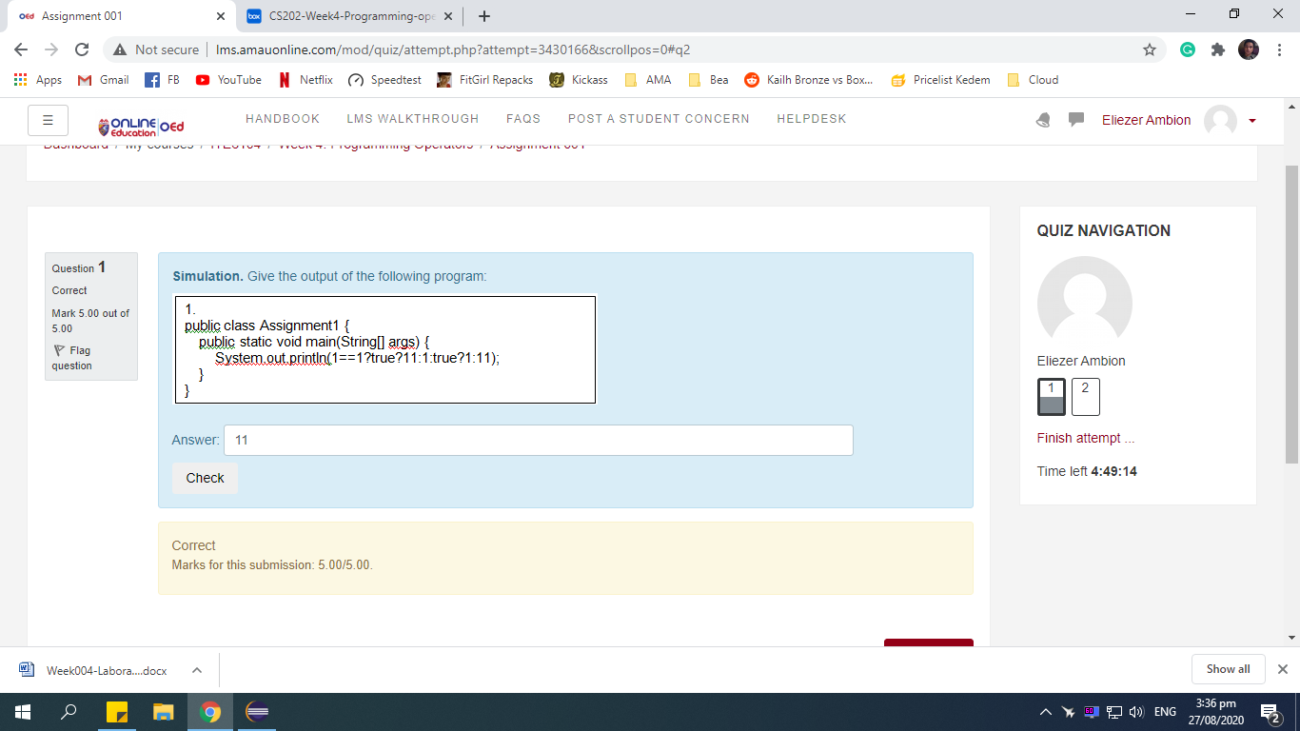

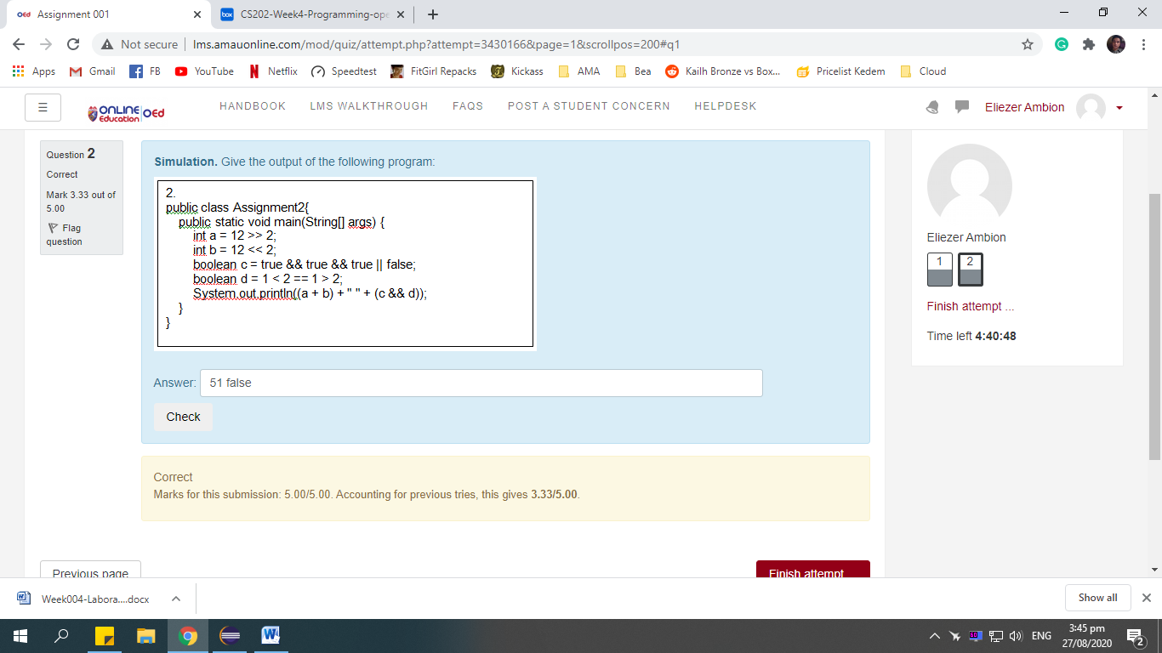

What was the initial name for the Java programming language?

c. Oak

What does Java generate after compiling the java source code?

e. Byte Code

What is the extension name of a Java Source code?

a. java

What is the input for Java Compiler?

e. Source Code

Which of the following is a jump statement in java?

e. break

JVM is responsible for

c. Interpreting bytecode

Since Java uses a virtual machine, what does that mean about the versatility of Java?

a. It can run most anywhere without modification.

Which of the following we are not allowed to write java source code?

a. Notepad

b. eclipse

c. BlueJ

d. NetBeans

e. None of the Above

The Java feature, "write once, run anywhere", is termed as

c. Platform independent

When was the officially released of Java?

b. 1995

What will happen if we compile the statement below?  
~System.out.println(“Hello World!”)

e. There will be a syntax error after compilation.

Which of the following is true about Runtime errors:

b. Runtime errors occur during run-time.

Which of the following is true about syntax errors:

b. Syntax errors are usually typing errors.

c. Incorrect capitalization leads to syntax error.

d. All of the above.

e. You will have syntax errors if you misspell the Java command.

What is the correct statement to compile Java program in command line?

a. javac HelloWorld.java

What is the correct statement to run Java program in command line?

a. java HelloWorld

What is the correct statement to set javac path in command line?

a. path=C:\Program Files\Java\jdk1.6.0_23\bin

Why do we need to set the path for javac in command line?

c. To make javac available or accessible in command line.

Can we directly compile codes from notepad?

c. No, We can only write codes in Notepad

Can we directly compile codes from NetBeans?

b. Yes, because we can call Java compiler from NetBeans

Which of the following is a valid identifier?

a. public

b. true

c. name

d. static

Which of the following is not Java Literal?

a. Character value

b. Float value

c. None of the above

d. Integer value

e. Boolean value

Which of the following is not a Java comment?

a. Single Line Comments

b. Multi-Line Comments

c. Declaration Comments

d. Documentation Comments

Which of the following a valid Java identifier?

Select one:

a. all of the above

b. $id

c. id_1

d. id

e. _id

Which of the following is not an escape sequence?

Select one:

a. \t

b. \f

c. none of the above

d. \b

Which of the following is not a valid Float value?

a. none of the above

b. 1.2345E+3

c. 1.23

d. 12345678910F

e. 3.4028235E+38F

Which of the following is not a java keyword?

a. goto

c. else

d. name

e. if

Which of the following is not a valid variable declaration in Java?

b. short x;

c. int x;

d. float x = 2.0D;

e. int x = 1;

What is floating-point literal?

a. An integer literal with decimal point.

b. All of the above

c. Can be express in scientific notation.

d. It could be double or float value.

e. By default it is double type.

Which of the following is not a primitive data type?

a. short

b. long

c. none of the above

d. String

e. byte

Which of the following is a valid nextInt() return value?

a. 1010

What type of value does the nextLine() returns?

c. String

_________ is implemented in at least two classes with inheritance relationship.

e. Overriding

Which of the following is a valid statement to accept String input?

b. String str = JOptionPane.showInputDialog("");

What will happen if you use JOptionPane. showInputDialog statement in your program?

a. The program will display an input dialog box that allows the user to input text and returns String value.

Which of the following method reads input from the user and return String value?

e. nextLine()

What will happen if you use JOptionPane.showMessageDialog statement in your program?

a. The program will display message dialog box.

Which of the following is a valid nextByte() return value?

b. 3

Which of the following is a valid statement to accept int input? Let us assume that we have declared scan as Scanner.

a. short num = scan.nextInt();

b. None of the above

c. short num = scan.nextShort();

d. int num = scan.getInt();

e. int num = scan.nextLong();

Which of the following is a valid nexDouble() return value?

a. 3.1416

b. floating-point literal

c. double value

d. 12.0

e. All of the above

Which is not a repetition control structure?

c. switch

Which of the following has the correct form for an if statement?

b. if (boolean_expression)

Which is not a decision control structure?

a. None of the above

b. if else-if else

c. switch

d. if

e. if else

Which statement will check if x is less than y?

a. if (x<y);

What will be the value of x after executing this code

for(int x=0; x<=10; x++) {} is run?

d. 11

float is one of Java's Primitive data types

True

what will be the output if you execute this code?

int x=1;

switch(x){

case 1:

                System.out.print(“1”);

case 2:

                System.out.print(“1”);

case 3:

                System.out.print(“1”);

default:

                System.out.print(“1”);

}

a. None of the above}

b. display 1234

c. display 1

d. display 1111

e. display nothing

What will be the output if you execute this code?

do{System.out.println("Hello World!");}while(true);

a. print "Hello World" infinitely

What will be the value of x after you execute this statement

int z=0; for(int x=0; x<10; x++) for(int y=0; y<x; y++) z*=(x*y);

a. None of the above

b. 236

c. 1

d. 512

e. 128

Which statement will check if x is equal to y?

a. if (x>y)

b. if (y>y)

c. none of the above

d. if (x!<y)

e. if (x<>y)

What will be the output if you execute this code?

do{System.out.println("Hello World!");}while(false);  
a. print "Hello World"

Java is a simple, object-oriented, portable and robust computer language.

True

Portable is one of Java's control structures

False

Which is not a repetition control structure?

b. while

c. loop

d. do-while

e. for

Java's control structures are branching, decision, and multithreaded.

False

Which of the following is not a Java Literal?

a. Integer value

b. Float value

c. Boolean value

d. None of the above

e. Character value

What will be the value of x after executing this code for(int x=0; x<10; x++) {} is run?

d. 10

A data type that can only have a value of either true or false.

Boolean

byte, short, int, and for are one of Java's Primitive data types.

False

Java SE is a Java Platform

True

Java is architecture neutral

True

It is used to store a specific value or literals that can be used later in a program.

Variable

Repetition is one of Java's control structures

True

Java is secured

True

Who developed Java?

James Gosling

for, while and do-while is part of Java's Repetition Control Structures

True

What do you call the most basic data type that can be used in Java language?\

Primitive

What will be the result if you execute this expression x=true ? 1 : 0;?

Select one:

a. 1

0 represents false and 1 is ture.

Statements that allow the program to decide which block of codes to be executed based from the given condition

Decision control structures

Statements that allows the program execute statements repeatedly.

Repetition Control Structures

Declare a two-dimensional integer [array](http://lms.amauonline.com/mod/page/view.php?id=42865) named *values* of size 6 columns and 4 rows.

c. int[ ][ ] values=new int[4][6];

Which of the following is a correct declaration of an [array](http://lms.amauonline.com/mod/page/view.php?id=42865)?

c. EmployeeRecord[ ][ ] er=new EmployeeRecord[10][10];

The length of an [array](http://lms.amauonline.com/mod/page/view.php?id=42865) is established when the [array](http://lms.amauonline.com/mod/page/view.php?id=42865) is created at __________.

a. runtime

How many elements could be assigned to an [array](http://lms.amauonline.com/mod/page/view.php?id=42865) location with 5 columns and 3 rows?

e. 15

Declare and initialize a *double* data type [array](http://lms.amauonline.com/mod/page/view.php?id=42865) named *numbers* with the following values: 23.35, 34.45, 56.77.

e. double[ ] numbers={23.35, 34.45, 56.77};

What is the output of the code snippet below:

            int[] intArray = { 1, 2, 3, 5, 6, 7 };

            for(int x = intArray.length-1; x>=0; x--){System.out.print(intArray[x]);}

c. 765321

Use the __________ statement when traversing through arrays.

c. for loop

What is the output of the code snippet below:

            int[] intArray = new int[10];

for(int x = 0; x<intArray.length; x++){System.out.print(intArray[x]);}

e. 0000000000

The __________ keyword allocates memory for the [array](http://lms.amauonline.com/mod/page/view.php?id=42865) being declared.

b. new

Which of the following [array](http://lms.amauonline.com/mod/page/view.php?id=42865) declarations is correct?

c. double[ ] grades;  
grades = new double[2];

What is the output of the code snippet below: void main(){test();test();} void test(){System.out.print(“1”);}

b. 11

Which of the following is a valid method name:

c. compute

What is the return value of this method: *int test(){return 1;}*?

e. 1

Which of the following shows a valid Overloading method?

c. void test(char x, int y){} void test(int x, char y){}

What is the return value of this method: public void sum(){*int x=1;*} ?

c. void

What is the output of the code snippet below:

void main(){

test(1.0);

test(1);}

void test(double x){

System.out.print(x); }

void test(int x){

System.out.print(x);}

d. 1.01

What is the output of the code snippet below:

            void main(){test(“11”);test(“1”);}

            void test(String x){System.out.print(x + x);}

c. 111111

What is the return type of this method: *int test(){return 1;}*?

c. int

Which of the following creates an instance of a class?

a. Object obj = new Object();

b. String str = new String();

c. Test t = new Test();

d. String str = new String();

e. All of the choices

Which of the following show casting object?

a. SuperClass sc = new SuperClass(); SubClass sbc = new SubClass(); sbc = (SubClass) sc;

b. Employee emp = new Employee(); VicePresident veep = new VicePresident(); veep = (VicePresident)emp;

c. All of the choices

d. (className)     object;

Which of the following will do implicit cast?

c. short x=1; int y = x;

Which of the following is the correct way to call the constructor of the parent class?

c. super()

What keyword is used to perform class inheritance?

a. extends

Which of the following [methods](http://lms.amauonline.com/mod/page/view.php?id=42868) is allowed to be overriden?

c. public void setName(){}

It is the ability of an object to have many forms?

e. Polymorphism

Which of the following is the correct way to use an interface?

b. public class Person implements [InterfaceName] {}

Which of the following statements is not true about Exception?

a. all of the above

b. The try block can be present without catch clause.

c. Finally clause is mandatory.

d. A catch clause can exist without a try statement.

Which of the following creates an instance of a class?

e. String s = new String();

What is the return type of this method: int demo(){return 1;} ?

c. int

Which of the following correctly accesses the last element stored in an [array](http://lms.amauonline.com/mod/page/view.php?id=42865) of 5 elements?

b. arrayName[4];

It is a block of code similar to a method that is called when an instance of an object is created

* Constructor

It is an event, which occurs during the execution of a program, that disrupts the normal flow of the program's instructions.

* Exception

It lets you create classes that are derived from other classes.

* Inheritance

What do you call a blueprint of an object?

* Class

public static void main(String [] args){

int[][] nums = {{1,2}, {1, 2}};

for (int x = 0; x<2; x++)

for(int y = 0; y<2; y++)

System.out.println(nums[x][y]);

* Answer: 1212

public static void main(String [] args){

int[] nums = {1,2,3,4};

for (int x = 1; x<nums.length; x++)

System.out.println(nums[x]);

* Answer 234

Which of the following declares an [array](http://lms.amauonline.com/mod/page/view.php?id=42865) of int named intArray?

d. int intArray[];

A block where it always executed whether exception is handled or not.

* Finally

It is the ability of an object to take on many forms.

* Polymorphism

Where should we place the code to avoid runtime error?

b. try block

public static void main(String [] args){

int[] nums = {1,2,3,4};

System.out.println(nums[0] + nums[1] + nums[2] + nums[3]);

* Answer: 10

public static void main(String [] args){

int[][] nums = {{1,2}, {1,2}};

System.out.println(nums[0][0] + "" + nums[0][1]);

* Answer: 12

What keyword is used to indicate the use of an interface?

d. implements